Step1:-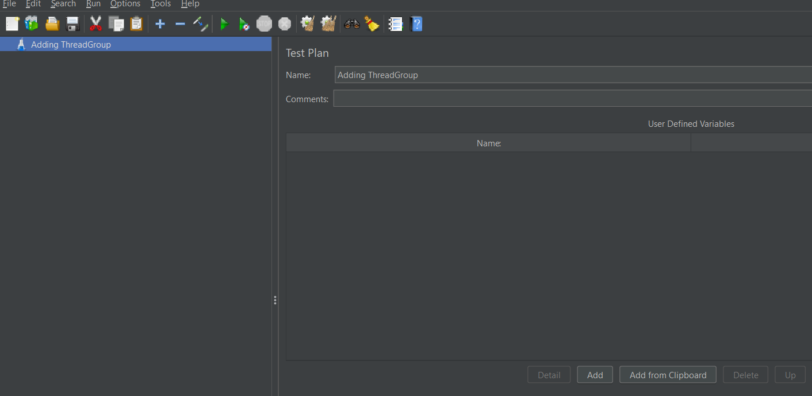

Step2:-Right click on the test plan

Click on Add

Click on Thread(Users)

Click on Thread Group

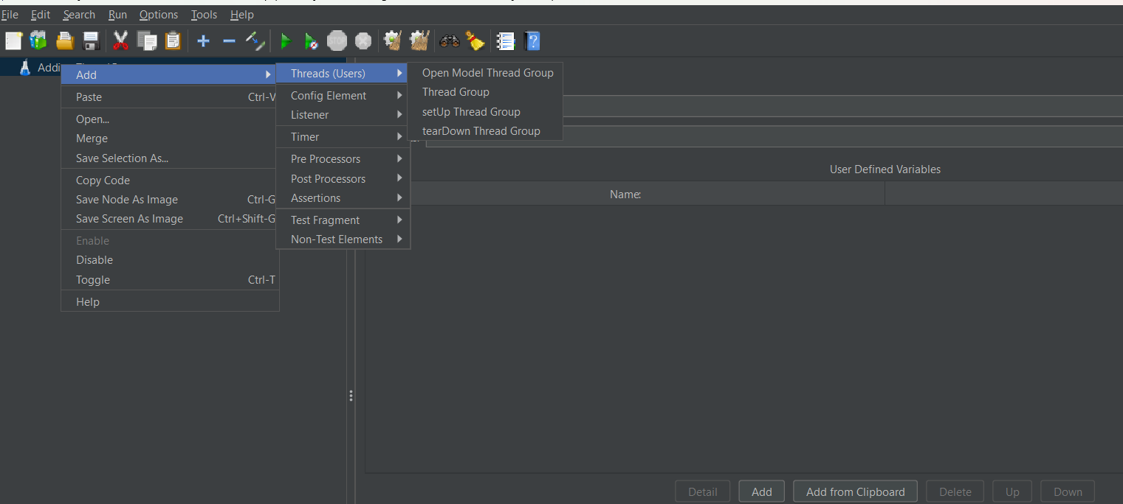

Step 3:-In Thread group

In Thread properties

We can load(threads)in Thread Properties

Number of Thread User :- 10 (we add 10 user in this scenario)

Ramp up periods(seconds):- 5

Loop count :-1

Tick on :- Same user on each iteration.

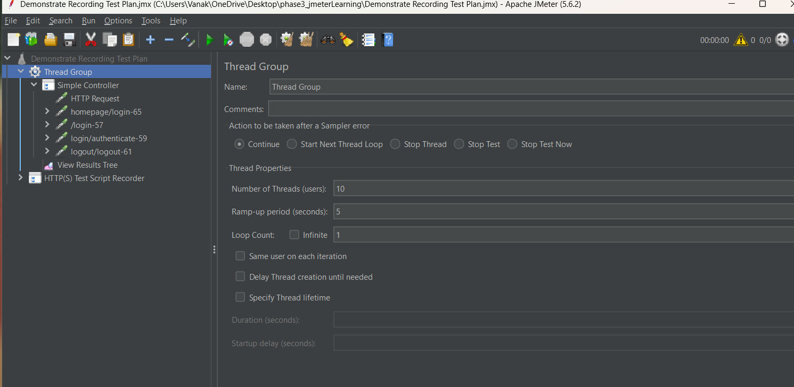

Step 4:-Add listner 🡪view Results Tree

Step 5:- click on run button.

